|  |  |
| --- | --- |
|  |  |

**Business Requirements**

SFA Migration to PRUforce

Version:

1.0

Department Owner:

IT

Updated:

24 July 2017

Kiki Novalia

**Approval**

By signing this section, the individuals listed below acknowledge that they have reviewed and approved the scope of the effort described in this Business Requirements (BR) for **SFA Migration to PRUforce**. The signatures below represent the approval for execution of this BRS:

|  |  |  |  |
| --- | --- | --- | --- |
| **Prepared by** | | | |
| **Name** | **Designation/Role** | **Date** | **Signature** |
|  | Business User/Requestor |  |  |
|  | Requestor SPV |  |  |
| **Reviewed by** | | | |
| **Name** | **Designation/Role** | **Date** | **Signature** |
|  | Requestor Manager |  |  |
| **Approved by** | | | |
| **Name** | **Designation/Role** | **Date** | **Signature** |
|  | Project Owner (HOD) |  |  |

*\*please do not remove, but add as necessary*

**Revision History**

*Please replace all revision history in table below once you use this template for your project purposes*

|  |  |  |  |
| --- | --- | --- | --- |
| Version No. | Date | Created by | Revision Description/ Reason for Revision |
| 1.0 |  | Kiki Novalia | Initial version |
|  |  |  |  |
|  |  |  |  |
|  |  |  |  |

**Distribution List**

This document shall be made available as soft copies to the following users below:

|  |  |  |  |
| --- | --- | --- | --- |
| **No.** | **Name** | **Designation/Role** | **Department** |
| 1. |  |  |  |
| 2. |  |  |  |
| 3. |  |  |  |

**TABLE OF CONTENT**

1 Introduction 1

1.1 Purpose 1

1.2 Objectives 1

1.3 Scope 1

1.4 Out of Scope 1

1.5 Assumptions, Dependencies, Constraints 1

2 Business Requirements 2

2.1 Reports 2

2.1.1 Orphan Policy List 2

2.1.1.1 Functionality and Requirement 2

2.1.2 Orphan Proposal List 2

2.1.2.1 Functionality and Requirement 2

2.1.3 Other Reports 3

2.1.3.1 Functionality and Requirement 3

2.1.3.2 List Expiry Credit Card 4

2.1.3.3 List Payment Rejection 5

2.1.3.4 List SMS Cancel Unit 1 5

2.1.3.5 List SMS Pending Requirement PHS Alteration & Revival 6

2.1.4 NPA Status 7

2.1.4.1 NPA Status 7

2.2 Policy 7

2.2.1 Insurance Charges 7

2.2.1.1 Functionality and Requirement 7

2.2.2 Feedback 9

2.2.2.1 Functionality and Requirement 9

2.3 Proposal 11

2.3.1 Feedback 11

2.3.1.1 Functionality and Requirement 11

2.4 Correspondence 12

2.4.1 Client’s Letter 12

2.4.1.1 Functionality and Requirement 12

2.4.1.2 Annual Transaction Report 13

2.4.1.3 Dishonor Letter 13

2.4.1.4 Notice 14

2.4.1.5 Surplus Tabarru* 14

2.4.1.6 Substandard Letter – Exclusion* 15

2.4.1.7 Substandard Letter – Rating* 16

2.4.2 Payment Reject List 16

2.4.2.1 Functionality and Requirement 16

# Introduction

## Purpose

## Objectives

## Scope

## Out of Scope

N/A

## Assumptions, Dependencies, Constraints

N/A

# Business Requirements

## Reports

### Orphan Policy List

#### Functionality and Requirement

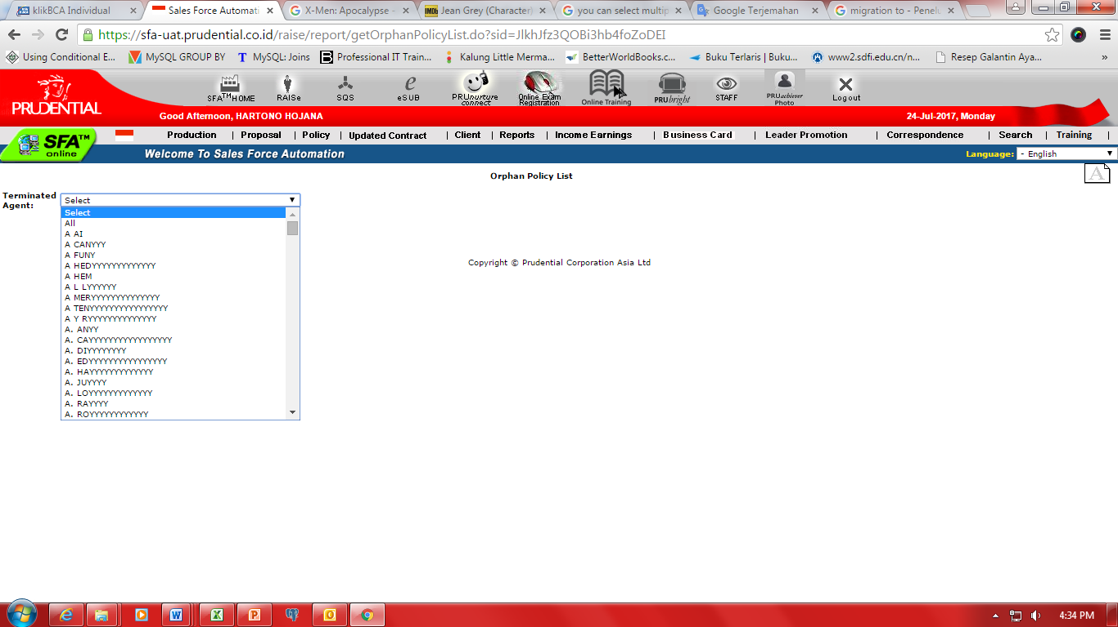

Figure 1 Orphan Policy List

1. Agent is able to view policy details of terminated agent by choosing one of agent name on the dropdown menu.
   1. System display list terminated agent of his/her unit consist of:
      1. Agent Name
      2. Contract Number
      3. Insurance Type (Currency)
      4. Policy Holder Name (Client Number)
      5. Instalment Premium (inclusive FPD)
      6. Single Premium
      7. Payment Frequency
      8. Payment Method
      9. Policy Status/ Premium Status
      10. Policy Inception Date
      11. Premium Paid To Date

### Orphan Proposal List

#### Functionality and Requirement

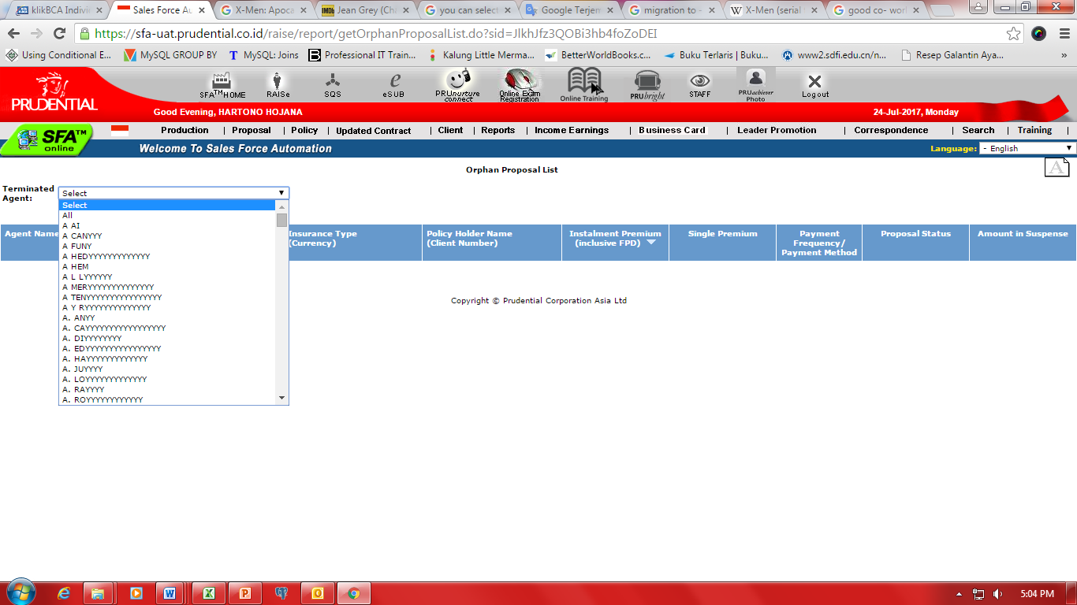

Figure 2 Orphan Proposal List

1. User is able to view proposal details of terminated agent by choosing one of agent name on the dropdown menu.
   1. System display list terminated agent of his/her unit consist of:
      1. Agent Name
      2. Proposal Number
      3. Reference Number
      4. Insurance Type (Currency)
      5. Policy Holder Name (Client Number)
      6. Instalment Premium (inclusive FPD)
      7. Single Premium
      8. Payment Frequency/ Payment Method
      9. Proposal Status
      10. Amount in Suspense

### Other Reports

#### Functionality and Requirement

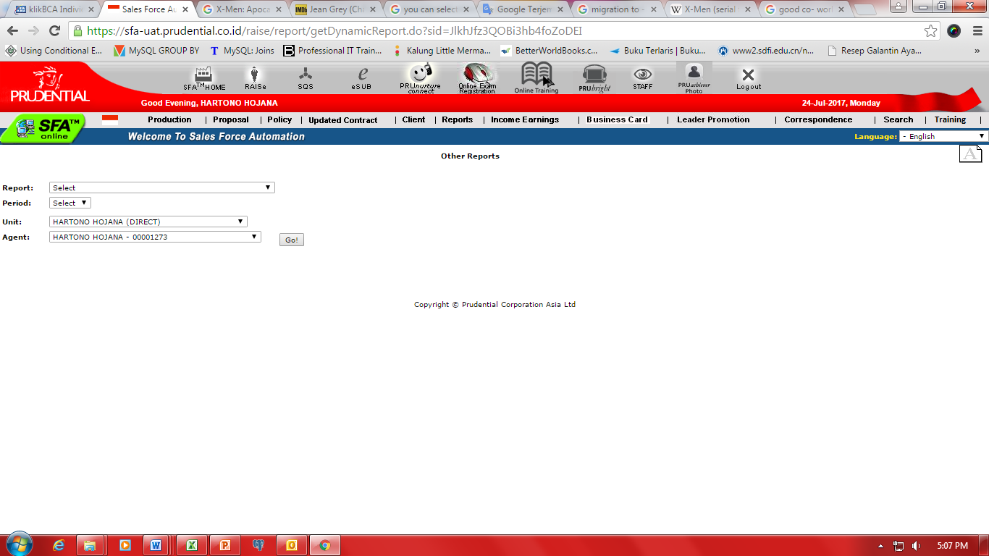

Figure 3 Other Reports

User is able to view report based on the following selection on Report dropdown menu:

1. List Expiry Credit Card
2. List Payment Rejection
3. List SMS Cancel Unit 1
4. List SMS Pending Requirement PHS Alteration & Revival

#### List Expiry Credit Card

##### Functionality and Requirement

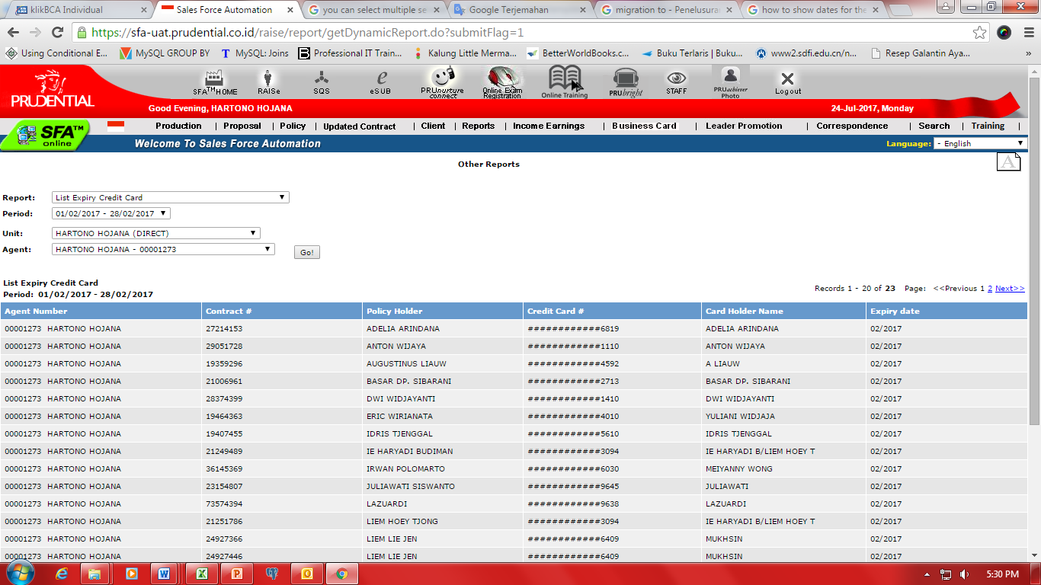

Figure 4 List Expiry Credit Card

1. Request of List of Expiry Credit Card can only be done 5 (five) years.
2. User is able to choose direct unit on Unit dropdown menu
3. User is able to choose Agent name on Agent dropdown menu
4. System will show List of Expiry Credit Card consist of:
   1. Agent Number Contract
   2. Policy Holder Credit Card
   3. Card Holder Name
   4. Expiry date

#### List Payment Rejection

##### Functionality and Requirement

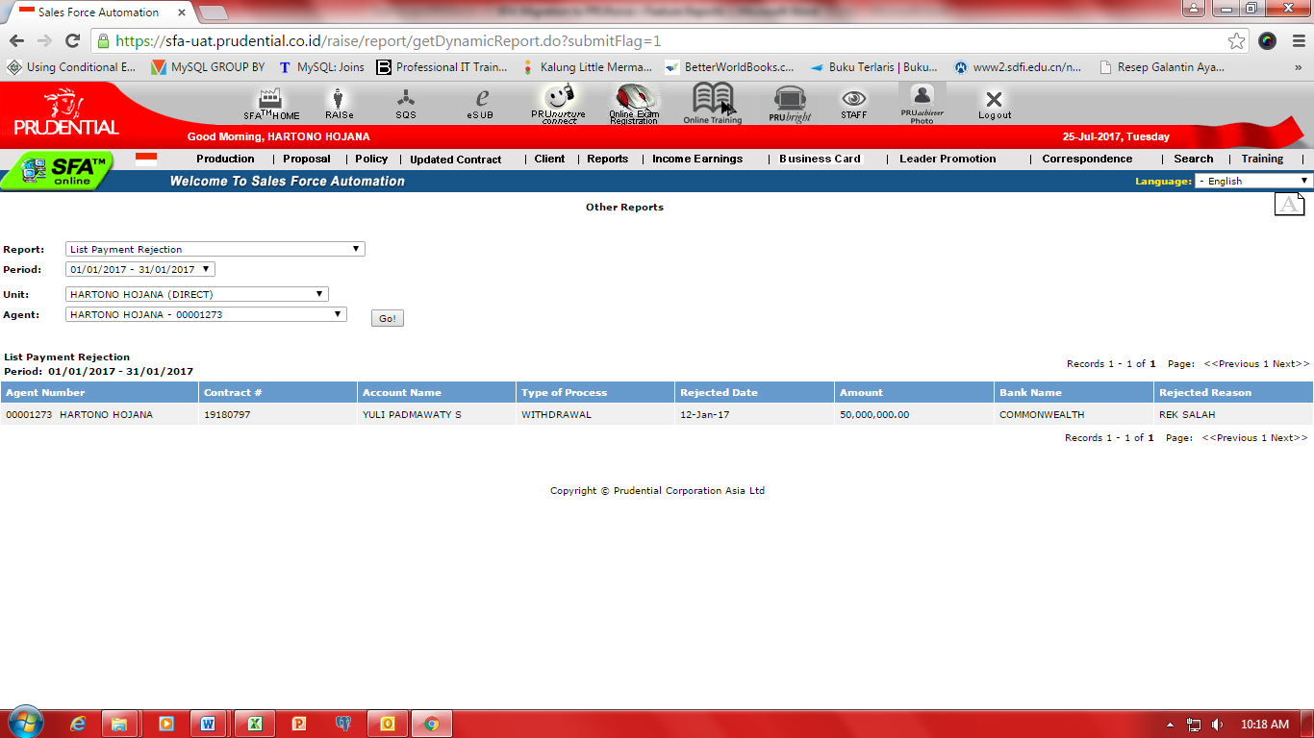

Figure 5 List Payment Rejection

1. Request of List of Payment Rejection can only be done for 3 (three) months.
2. User is able to choose direct unit on Unit dropdown menu
3. User is able to choose Agent name on Agent dropdown menu
4. System will show List of Payment Rejection consist of:
   1. Agent Number Contract
   2. Account Name
   3. Type of Process
   4. Rejected Date
   5. Amount
   6. Bank Name
   7. Rejected Reason

#### List SMS Cancel Unit 1

##### Functionality and Requirement

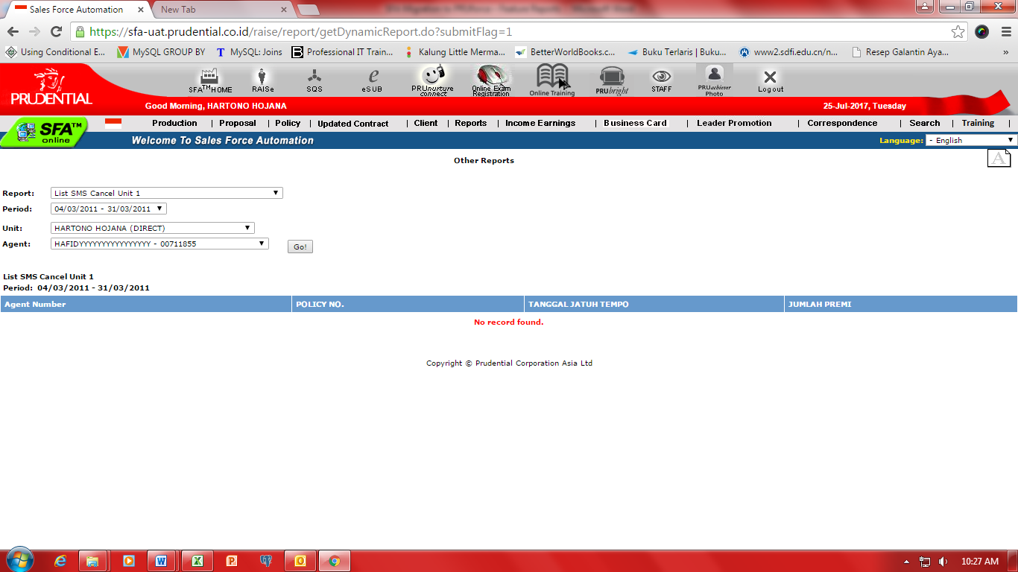

Figure 6 List SMS Cancel Unit 1

#### List SMS Pending Requirement PHS Alteration & Revival

##### Functionality and Requirement

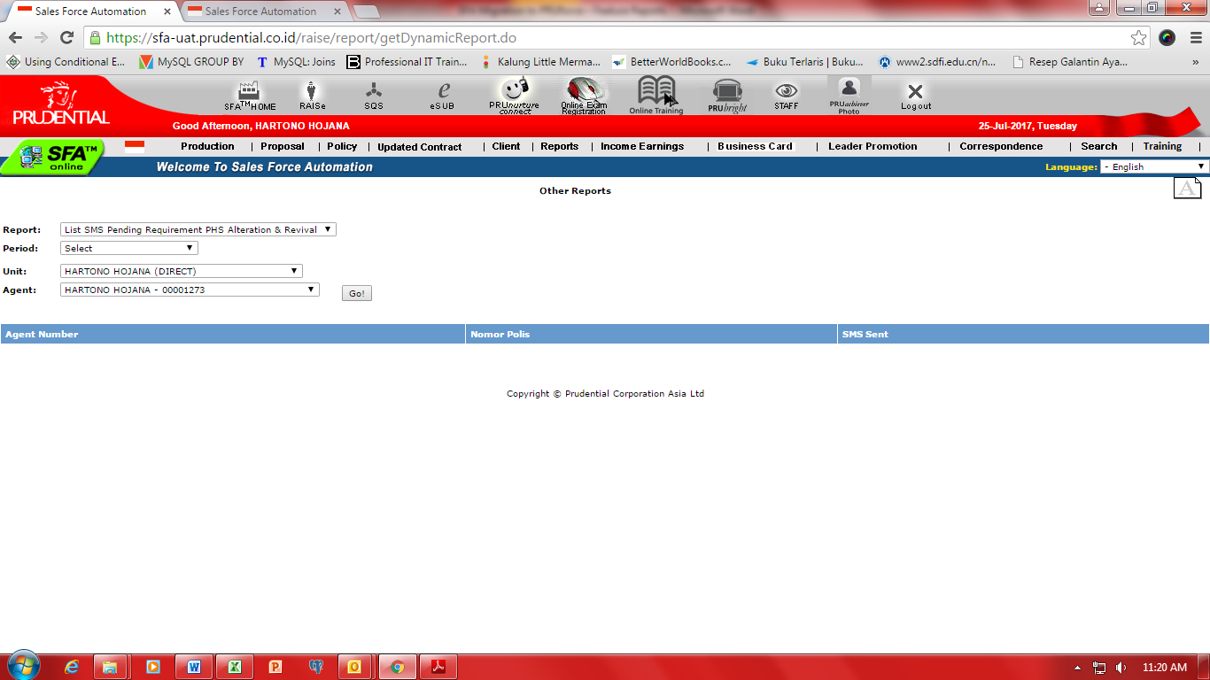

1. Request of List of SMS Pending Requirements PHS Alteration & Revival can only be done for 4 (four) months.
2. User is able to choose direct unit on Unit dropdown menu
3. User is able to choose Agent name on Agent dropdown menu
4. System will show List of SMS Pending Requirements PHS Alteration & Revival consist of:
   1. Agent Number
   2. Policy Number
   3. SMS Sent

### NPA Status

#### NPA Status

##### Functionality and Requirement

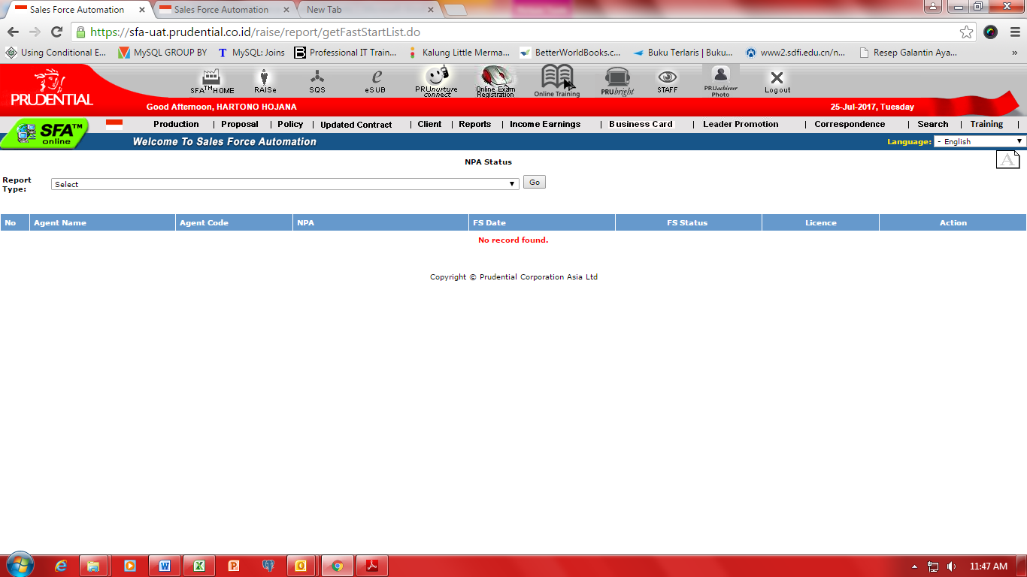

Figure 7 NPA Status

1. User can view NPA status of Agent based on the following selection on Report dropdown menu:
   1. Agent Code Status that already passed FS but have no license
      1. Agent has not taken AAJI Exam yet.
      2. Agent who have not passed AAJI Exam
   2. Agent Code Status that have not passed FS
   3. NPA Code status that already attended FS but have no Agent Code/have not sent the Formulir Pengajuan Agen (FPA)
2. List of Agent consist of:
   1. Agent Name
   2. Agent Code
   3. NPA
   4. FS Date
   5. FS Status
   6. Licence
   7. Action

## Policy

### Insurance Charges

#### Functionality and Requirement

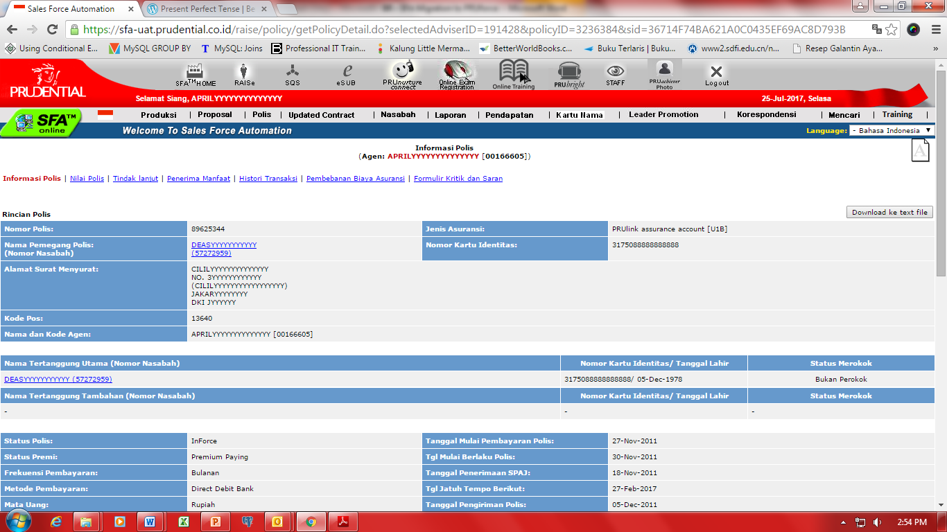

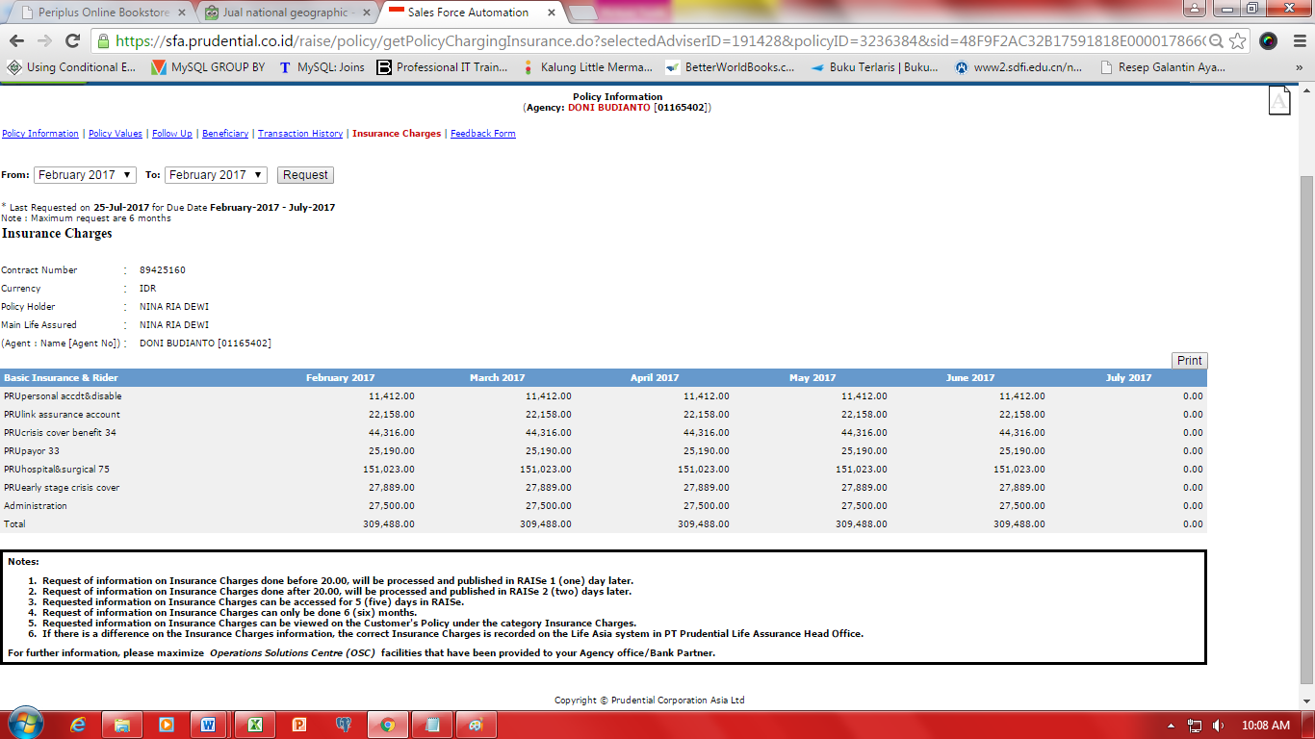

Figure 8 Insurance Charges

1. Request of information on Insurance Charges done before 20.00, will be processed and published in RAISe 1 (one) day later.
2. Request of information on Insurance Charges done after 20.00, will be processed and published in RAISe 2 (two) days later.
3. Requested information on Insurance Charges can be accessed for 5 (five) days in RAISe.
4. Request of information on Insurance Charges can only be done 6 (six) months.
5. Requested information on Insurance Charges can be viewed on the Customer's Policy under the category Insurance Charges.
6. If there is a difference on the Insurance Charges information, the correct Insurance Charges is recorded on the Life Asia system in PT Prudential Life Assurance Head Office.
7. User is able to download information on Insurance Charges as pdf file.

### Feedback

#### Functionality and Requirement



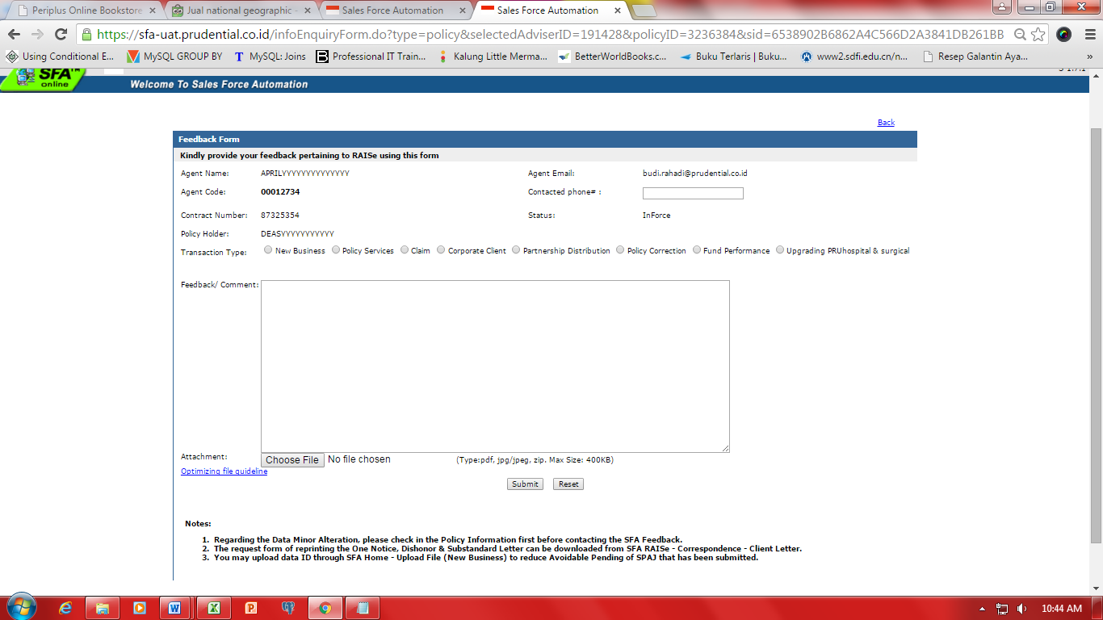

Figure 9 Feedback

1. Agent types who can send Feedback are **AAD** and **AAM** only.
2. Agent Name, Agent Code, Policy Number, Policy Holder Name, Email Agent, Policy Status is pre-populated except phone number.
3. User is able to choose type of transaction for the feedback as follow:
   1. New Benefit:
      1. NB – Underwriting
      2. NB - Pembayaran Premi Pertama
      3. NB - Pengiriman Polis
      4. NB - Surat Penawaran Substandard – Rating
      5. NB - Surat Penawaran Substandard – Exclusion
   2. Manfaat Polis:
      1. PHS - Penarikan Dana
      2. PHS - Pembatalan Polis
      3. PHS - Top Up
      4. PHS - Pemulihan / Perubahan
      5. PHS - Cuti Premi
      6. PHS - Cara Pembayaran
      7. PHS - Surat Gagal Debet
      8. PHS - Surat Penyataan Transaksi
      9. PHS - Pembayaran Premi di Muka
      10. PHS - Perubahan Minor
   3. Klaim:
      1. CL – Klaim Badan Usaha
   4. Badan Usaha:
      1. Badan Usaha – Undewriting
      2. Badan Usaha - Pembayaran Premi Pertama
      3. Badan Usaha - Pengiriman Polis
      4. Badan Usaha – Klaim
      5. Badan Usaha - Surat Penawaran Substandard – Rating
      6. Badan Usaha - Surat Penawaran Substandard – Exclusion
      7. Badan Usaha - Surat Gagal Debet
      8. Badan Usaha - Surat Penyataan Transaksi
      9. Badan Usaha - Penarikan Dana
      10. Badan Usaha - Pembatalan Polis
      11. Badan Usaha - Top Up
      12. Badan Usaha - Pemulihan / Perubahan
      13. Badan Usaha - Cuti Premi
      14. Badan Usaha - Cara Pembayaran
      15. Badan Usaha - Pembayaran Premi di Muka
      16. Badan Usaha - Perubahan Minor
   5. Partnership Distribution:
      1. PD – Undewriting
      2. PD - Pembayaran Premi Pertama
      3. PD - Pengiriman Polis
      4. PD – Klaim
      5. PD - Surat Penawaran Substandard – Rating
      6. PD - Surat Penawaran Substandard – Exclusion
      7. PD - Surat Gagal Debet
      8. PD - Surat Pernyataan Transaksi
      9. PD - Penarikan Dana
      10. PD - Pembatalan Polis
      11. PD - Top Up
      12. PD - Pemulihan / Perubahan
      13. PD - Cuti Premi
      14. PD - Cara Pembayaran
      15. PD - Pembayaran Premi di Muka
      16. PD - Perubahan Minor
   6. Koreksi Polis:
      1. PC - Revisi Polis
   7. Kinerja Dana:
      1. FP - Kinerja Dana
   8. Peningkatan Manfaat Kesehatan PRUhospital & surgical:
      1. HS - Peningkatan Manfaat Kesehatan PRUhospital & surgical
4. User is able to attach pdf file, image and zip file along with his/her feedback.
5. Admin will respond the feedback by sending email to User email address.

## Proposal

### Feedback

#### Functionality and Requirement

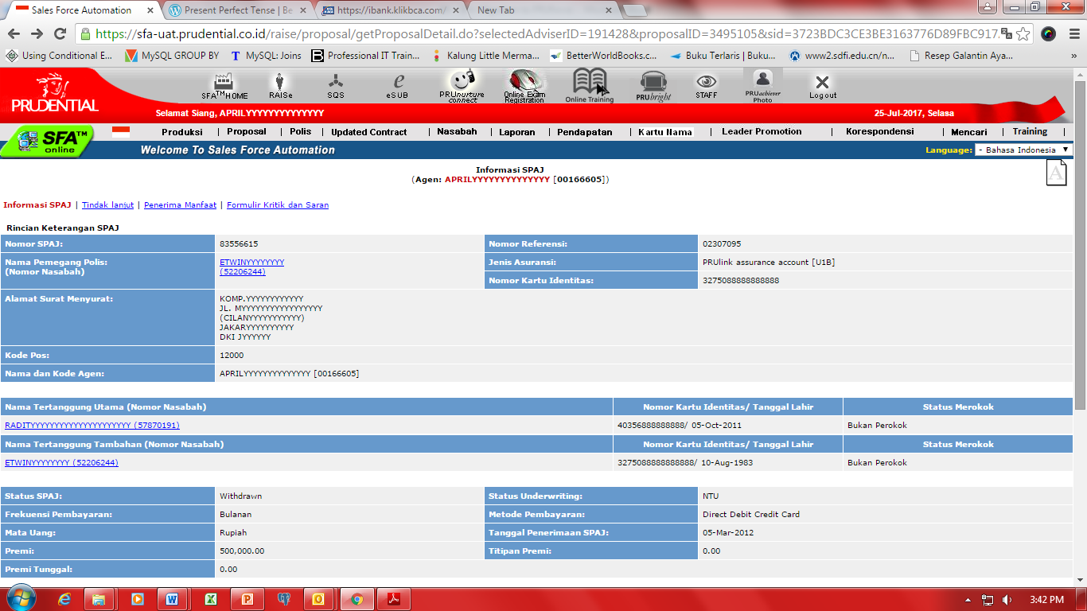

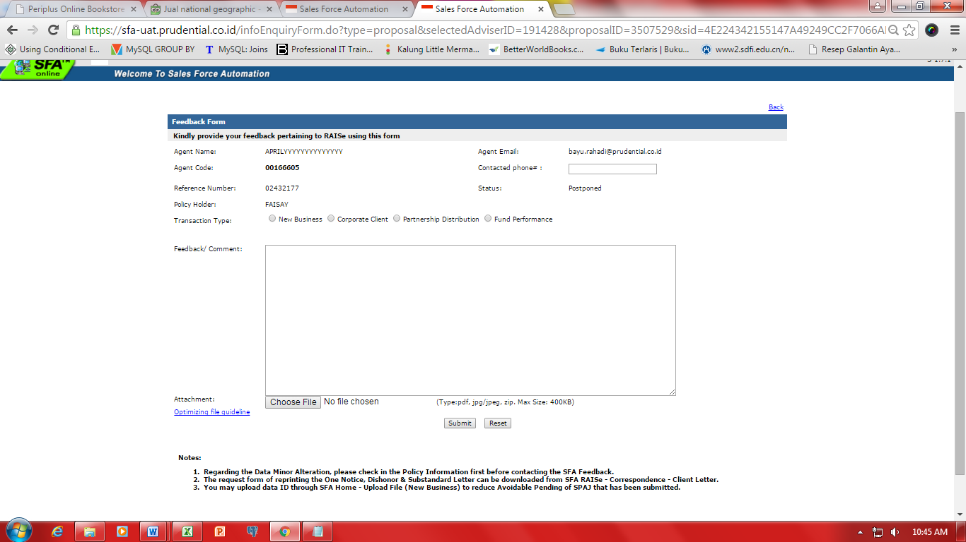

Figure 10 Feedback

1. Agent types who can send Feedback are **AAD** and **AAM** only.
2. Agent Name, Agent Code, Policy Number, Policy Holder Name, Email Agent, Policy Status is pre-populated except phone number.
3. User is able to choose type of transaction for the feedback as follow:
   1. New Business
   2. Badan Usaha
   3. Partnership Distribution
   4. Kinerja Dana
4. User is able to attach pdf file, image and zip file along with his/her feedback.
5. Admin will respond the feedback by sending email to Agent email address.

## Correspondence

### Client’s Letter

#### Functionality and Requirement

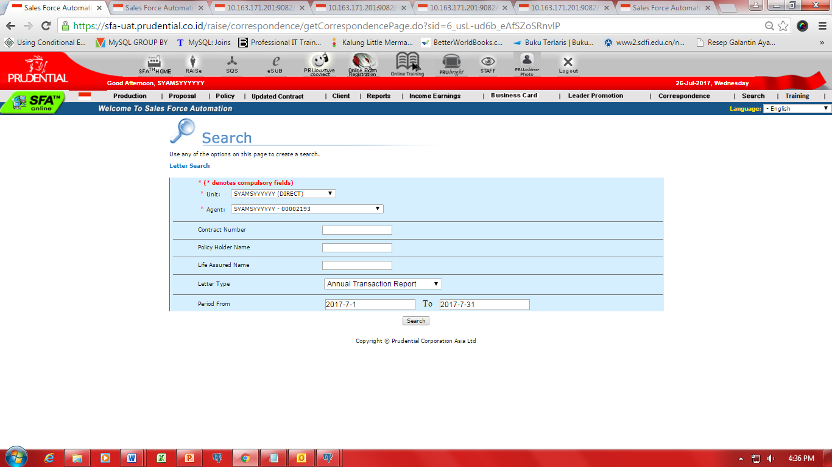

Figure 11 Client's Letter

User can download Client’s Letter of Customer's policy based on letter type as follow:

1. Annual Transaction Report
2. Dishonor Letter
3. Notice
4. Surplus Tabarru
5. Substandard Letter – Exclusion
6. Substandard Letter - Rating

Disclaimer / Note

A password is required to open Client’s Letter of Customer's policy.

For Individual Policy

The password for Client’s Letter is XXXXDDMmm (example: 567809Dec) where :

* XXXX is the last 4 digits of your Customer's SPAJ number
* DD is the two digits of the Policy Holder's date of birth
* Mmm is the first 3 letters of the Policy Holder's birth month in English. The first letter is uppercase and the rest are lowercase, example Dec

For Corporate Policy

The password is the last 6 digit of your Customer's policy number.

#### Annual Transaction Report

##### Functionality and Requirement

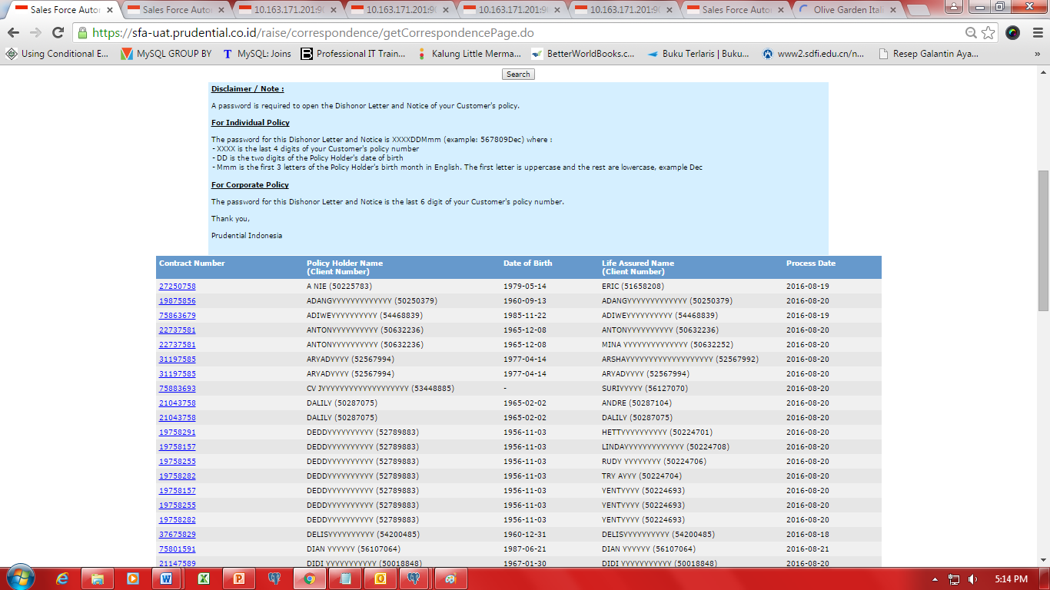

Figure 12 Annual Transaction Report

After user enter Contract number, Policy holder name or Life assured name, Letter type and period, system will display list of policy holder consist of:

1. Contract Number
2. Policy Holder Name
3. Date of Birth
4. Life Assured Name
5. Process Date

When user clicks on contract number, system display PDF files of Dishonor Letter and Notice of Customer's policy in the browser window.

#### Dishonor Letter

##### Functionality and Requirement

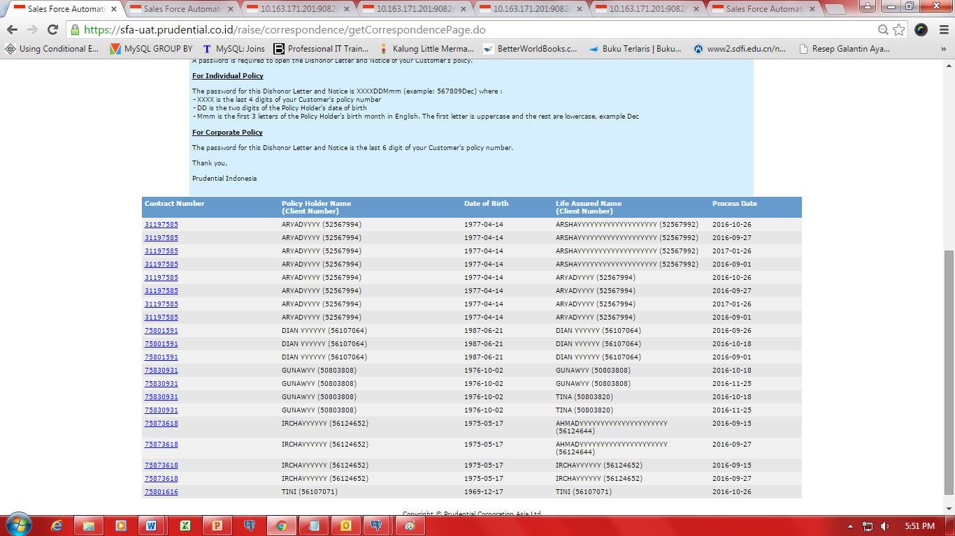

Figure 13 Dishonor Letter

After user enter Contract number, Policy holder name or Life assured name, Letter type and period, system will display list of policy holder consist of:

1. Contract Number
2. Policy Holder Name
3. Date of Birth
4. Life Assured Name
5. Process Date

When user clicks on contract number, system display PDF files of Dishonor Letter and Notice of Customer's policy in the browser window.

#### Notice

##### Functionality and Requirement

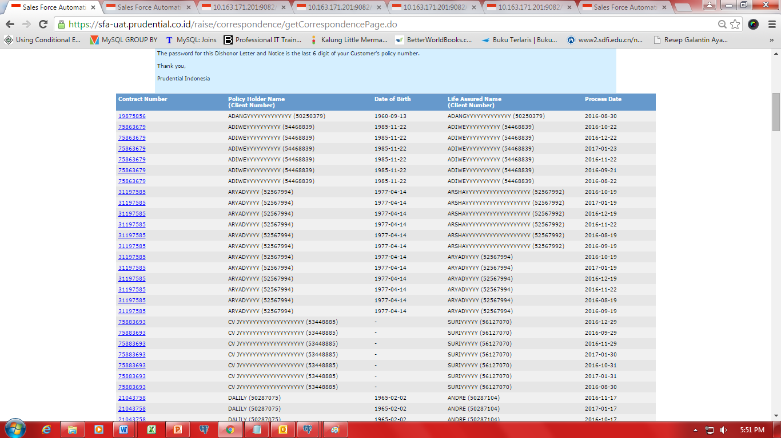

After user enter Contract number, Policy holder name or Life assured name, Letter type and period, system will display list of policy holder consist of:

1. Contract Number
2. Policy Holder Name
3. Date of Birth
4. Life Assured Name
5. Process Date

When user clicks on contract number, system display PDF files of Dishonor Letter and Notice of Customer's policy in the browser window.

#### Surplus Tabarru*

##### Functionality and Requirement



After user enter Contract number, Policy holder name or Life assured name, Letter type and period, system will display list of policy holder consist of:

1. Contract Number
2. Policy Holder Name
3. Date of Birth
4. Life Assured Name
5. Process Date

When user clicks on contract number, system display PDF files of Surplus Tabarru of Customer's policy in the browser window.

#### Substandard Letter – Exclusion*

##### Functionality and Requirement



After user enter Contract number, Policy holder name or Life assured name, Letter type and period, system will display list of policy holder consist of:

1. Contract Number
2. Policy Holder Name
3. Date of Birth
4. Life Assured Name
5. Process Date

When user clicks on contract number, system display PDF files of Substandard Letter – Exclusion of Customer's policy in the browser window.

#### Substandard Letter – Rating*

##### Functionality and Requirement



After user enter Contract number, Policy holder name or Life assured name, Letter type and period, system will display list of policy holder consist of:

1. Contract Number
2. Policy Holder Name
3. Date of Birth
4. Life Assured Name
5. Process Date

When user clicks on contract number, system display PDF files of Substandard Letter – Rating of Customer's policy in the browser window.

### Payment Reject List

#### Functionality and Requirement

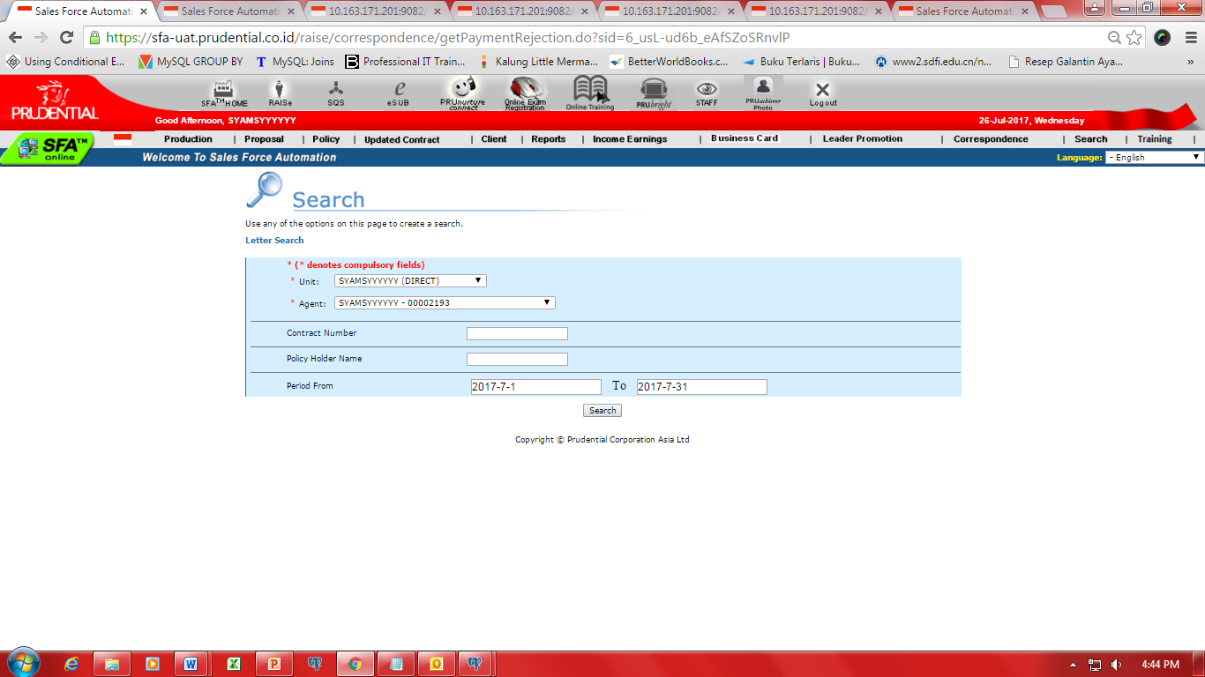

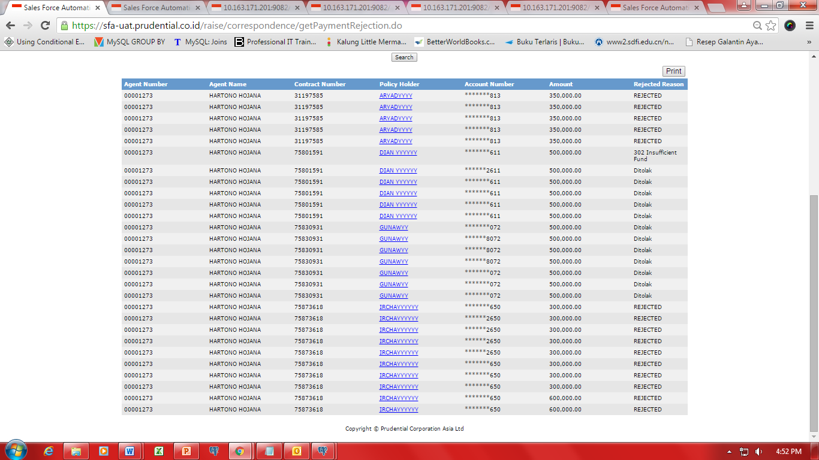

Figure 14 Payment Reject List

1. User can view Payment Reject List by entering Unit, Agent, Contract Number, Policy Holder Name, and Period. Payment Reject List consists of:
   1. Agent Number
   2. Agent Name
   3. Contact Number
   4. Policy Holder
   5. Account Number
   6. Amount
   7. Rejected Reason
2. When user clicks on contract number, system display PDF files of Payment Reject letter of Customer's policy in the browser window.
3. User can print Payment Reject List by clicking on “Print” button as shown in image below.

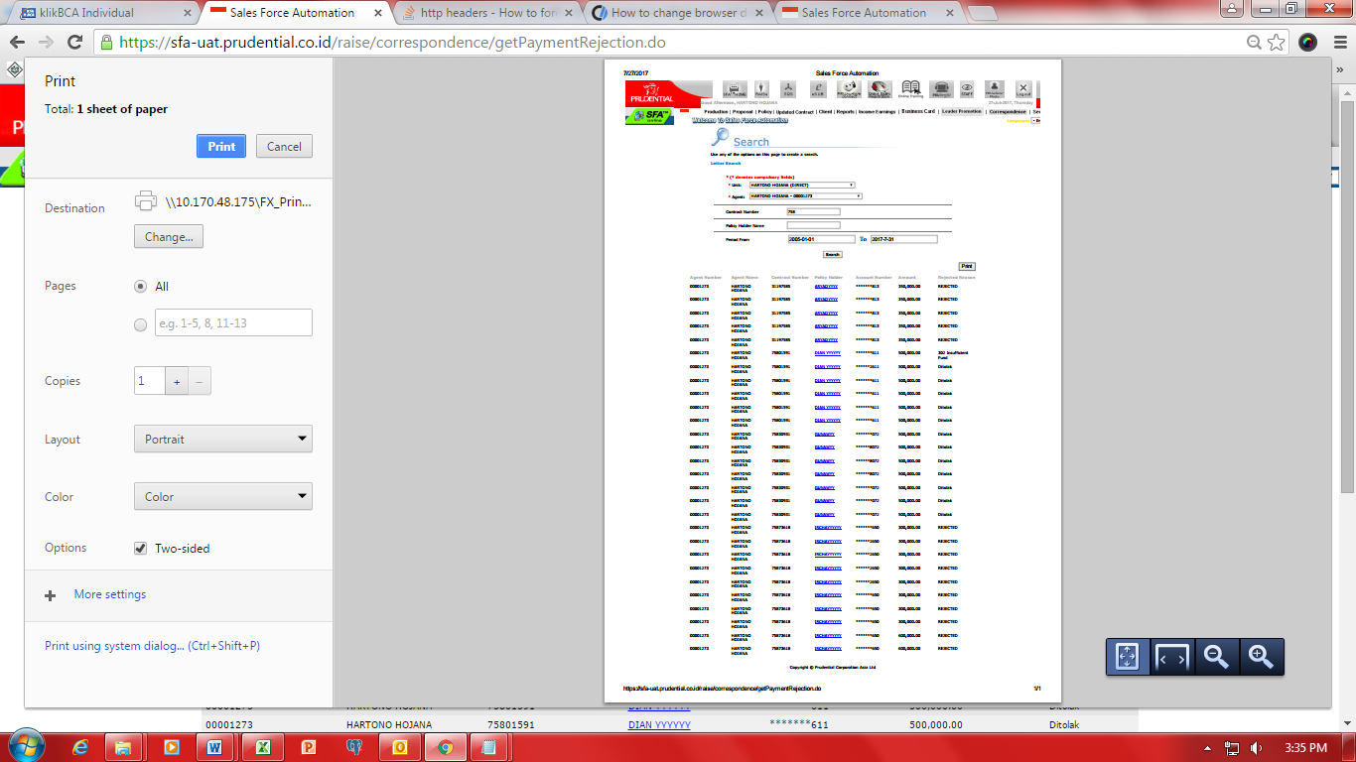

Figure 15 Print Payment Reject List

## Update Contract

### Update Contract

#### Functionality and Requirement

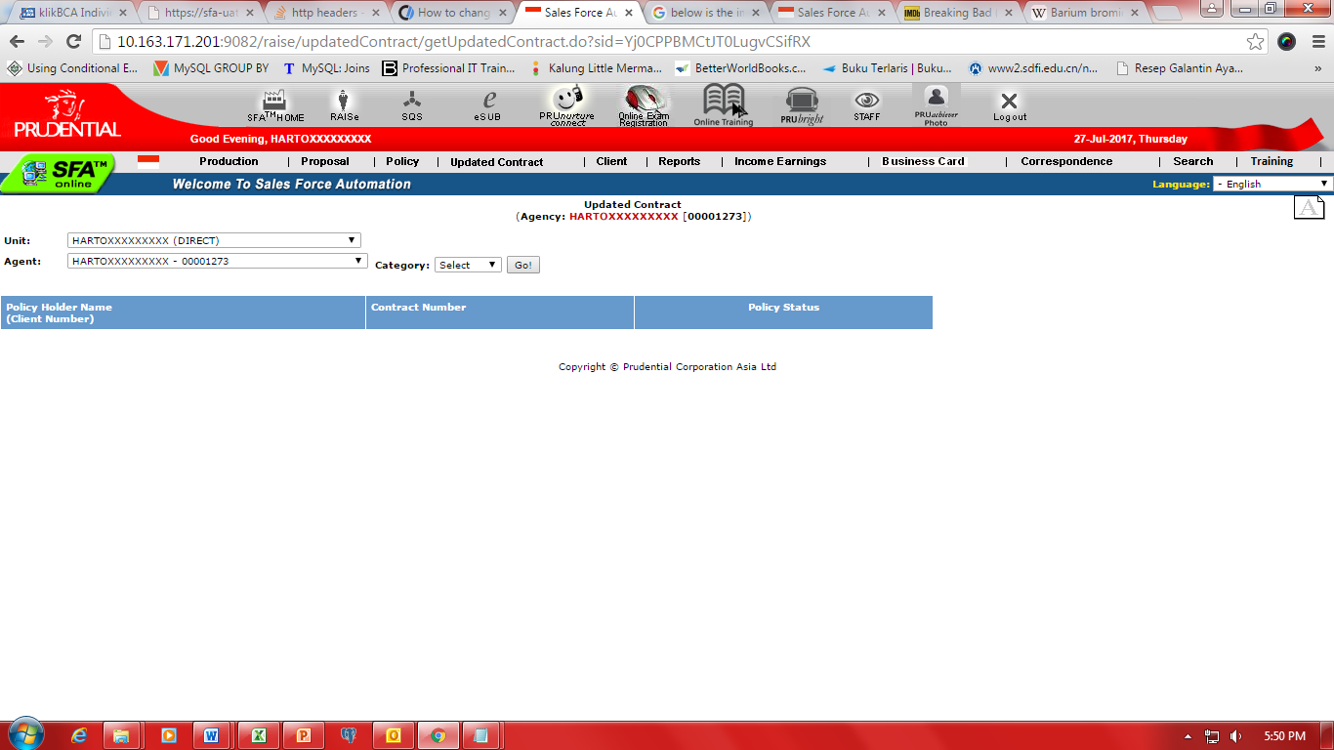

Figure 16 Update Contract

User can view list of Policy or proposal that has been updated as per current date after selecting Unit, Agent and Category (Proposal, Policy). List of Policy or proposal consist of:

1. Policy Holder Name
2. Contract Number
   1. On click contract number will navigate to policy detail
3. Policy Status

## Log PRUforce

### Download & PRUforce ID

#### Functionality and Requirement

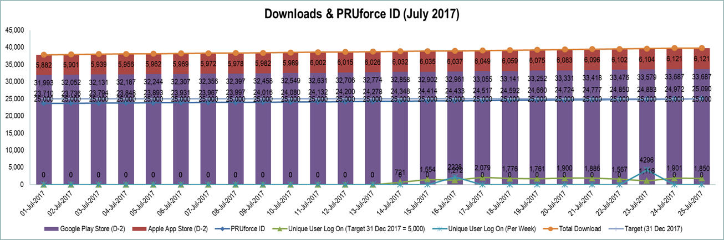

Figure 17 Download & PRUforce ID

User is able to see statistic illustrates the number of how many times PRUforce application is downloaded and PRUforce ID is created during the current month. Below are the details:

1. Date: Show date during the current month
2. Google Play Store (D-2): show number of how many times PRUforce application is downloaded on Google Play Store from current date - 2
3. Apple App Store (D-2): show number of how many times PRUforce application is downloaded on Apple App Store from current date - 2
4. PRUforce ID: show number of how many PRUforce ID is created per day
5. Unique User Log On: show number of Agents who have logged in to PRUforce app per day.
   1. Individual visitor to PRUforce app who is counted as a single visitor irrespective of the number of times he or she revisits PRUforce.
6. Unique User Log On (Per Week): show number of users who have logged in to PRUforce app per week.
7. Total Download: show total number how many times PRUforce application is downloaded on Google Play Store and Apple App Store.

### AOB

#### Functionality and Requirement

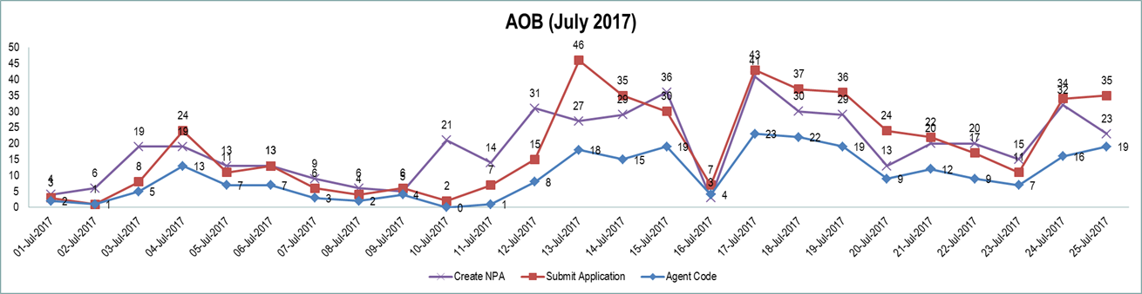

Figure 18 AOB

User is able to see statistic illustrates regarding Agent on Boarding activities during the current month. Below are the details:

1. Date: Show date during the current month
2. Create NPA: show number of how many NPA is created
3. Submit Application: show number of candidates submit the application
4. Agent Code: show number of how many Agent Code is created

### Top Page Hit

#### Functionality and Requirement

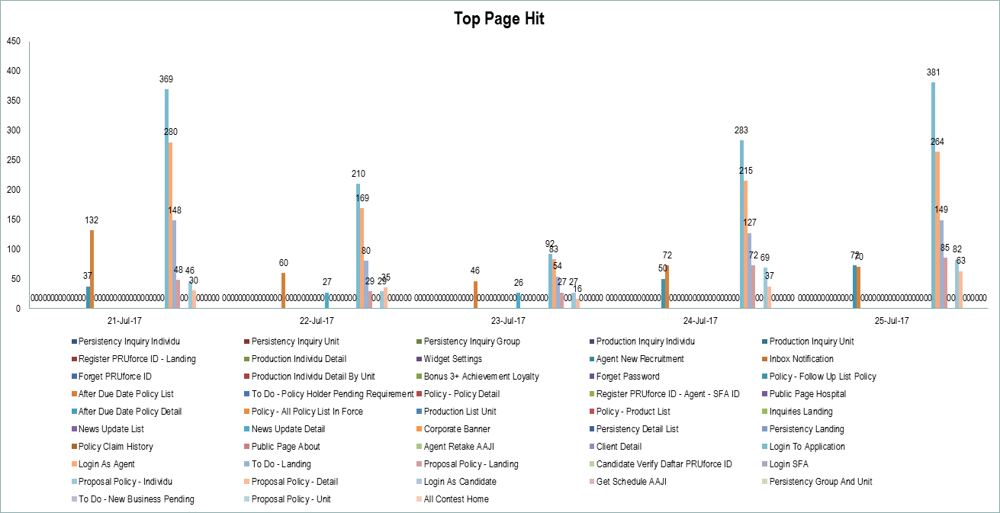

Figure 19 Top Page Hit

Once an Agent arrives at PRUforce app, each individual page an Agent hits is tracked as a page hit by system.